Government Engineering College, Thrissur
CS333– Application Software Development Lab
Documentation -
Exp 1 & 2– DDL, DQL & DML commands

Date of Submission
14 September 2020

Submitted By
Kowsik Nandagopan D
Roll No 31
TCR18CS031
GECT CSE S5

Experiment 1

AIM
Creation of database using DDL Commands and write DQL queries to retrieve information from the database

Description
Creation of table using the DDL commands like CREATE DATABASE. Getting information about the database using DESCRIBE keyword. Here I have created the database for the Open PPM project. As explained in the introductory documentation Open PPM is Project Portfolio Management Tool for small IT companies

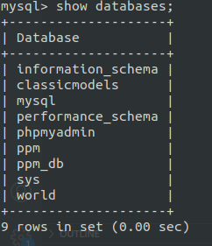
Output / Screenshots
(11 Pages)

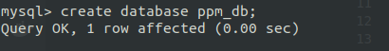

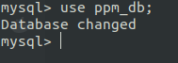

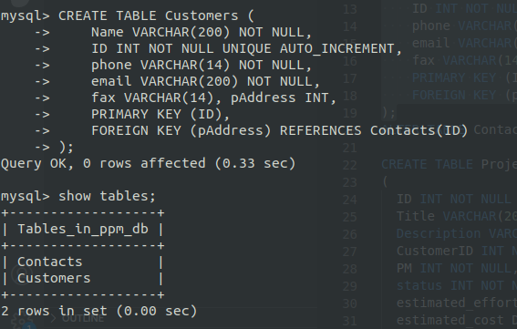

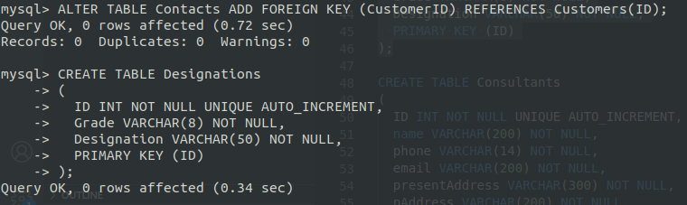

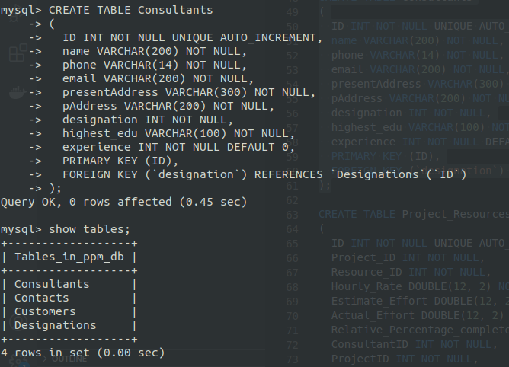

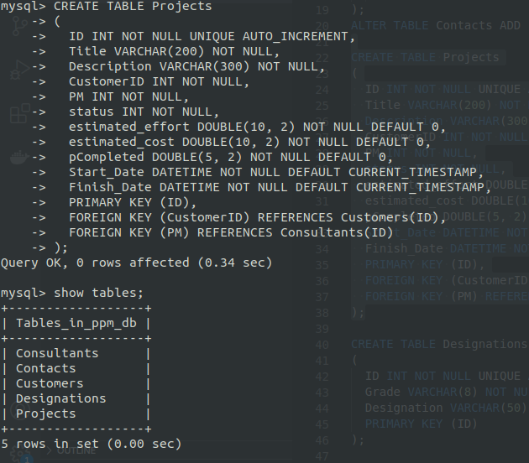

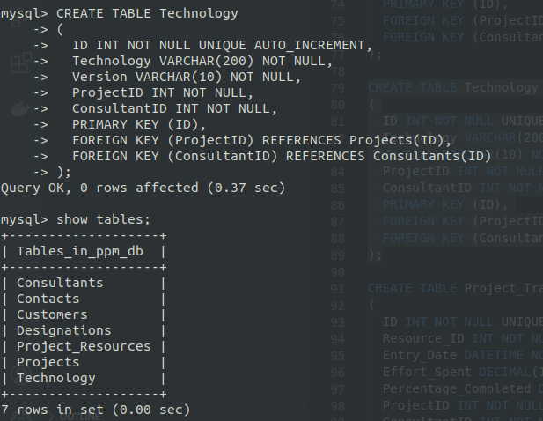

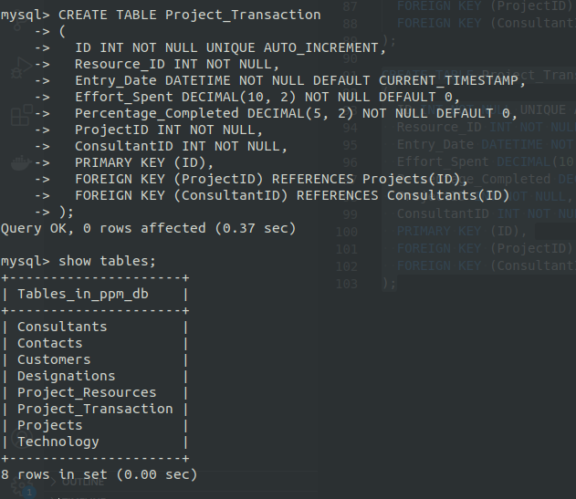
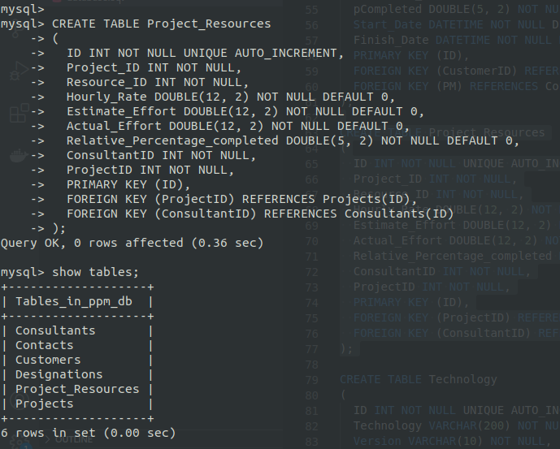
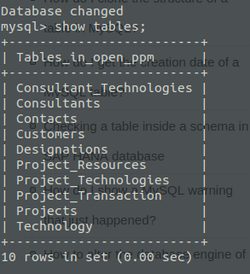

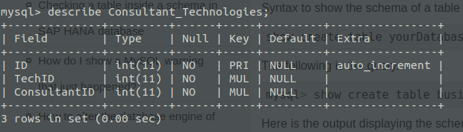

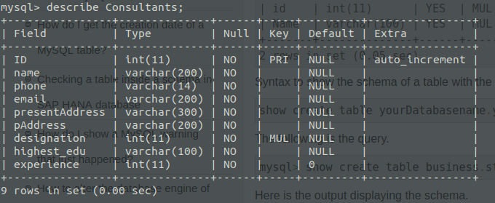
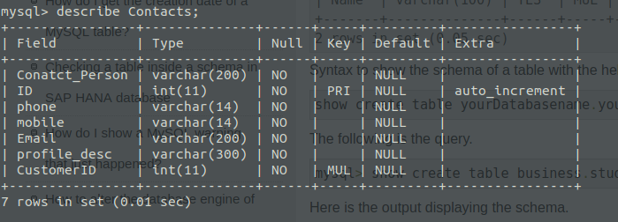
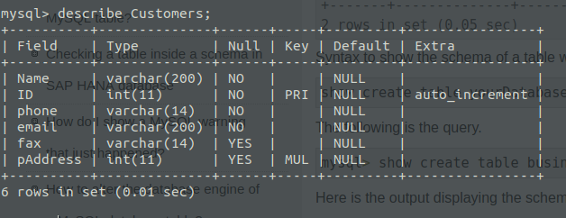
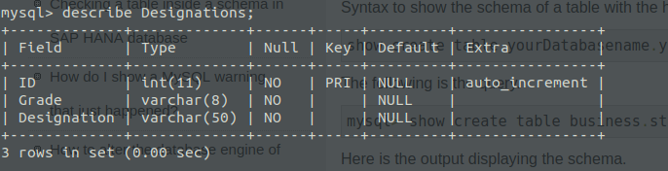
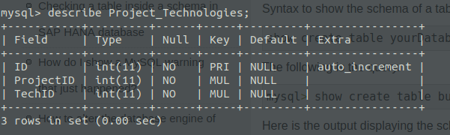
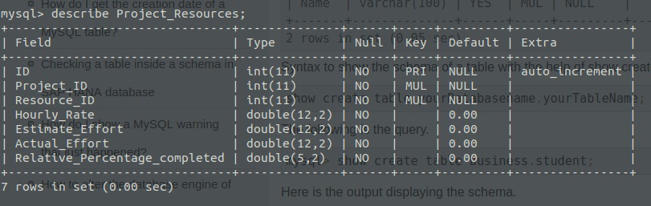

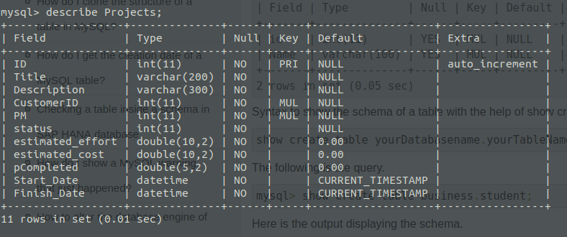
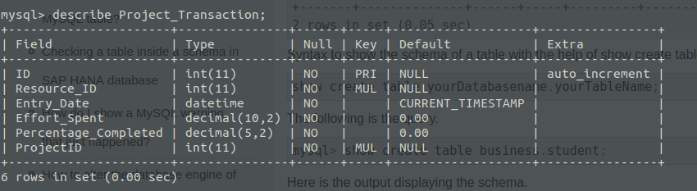
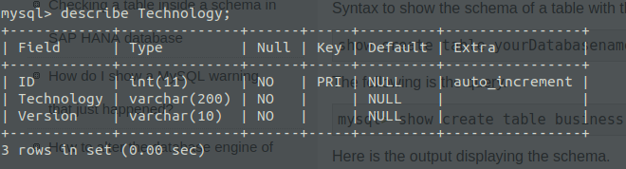

Experiment 2

AIM
Performing DML Commands like Insertion, deletion, Modification, Altering and updating based on conditions.

Description
Insertion, Deletion, Modification etc.. on the table created in the Exp 1. Here we will be using the SQL Commands like INSERT, DELETE, UPDATE, ALTER on the tables to query the data from the tables created in the first part of this project.

Output / Screenshots
(7 Pages)
